EX NO:12
DATE:
AFRICAN MOBILE DATA VISUALIZATION
AIM: To visualize the profit of each country along with its sales trends using the African Mobile Data.xlsx dataset in Tableau, in order to compare country-wise performance and identify changes in sales over time.
Using “African Mobile Data.xslx dataset”, visualize the profit of each country with their sales trend.
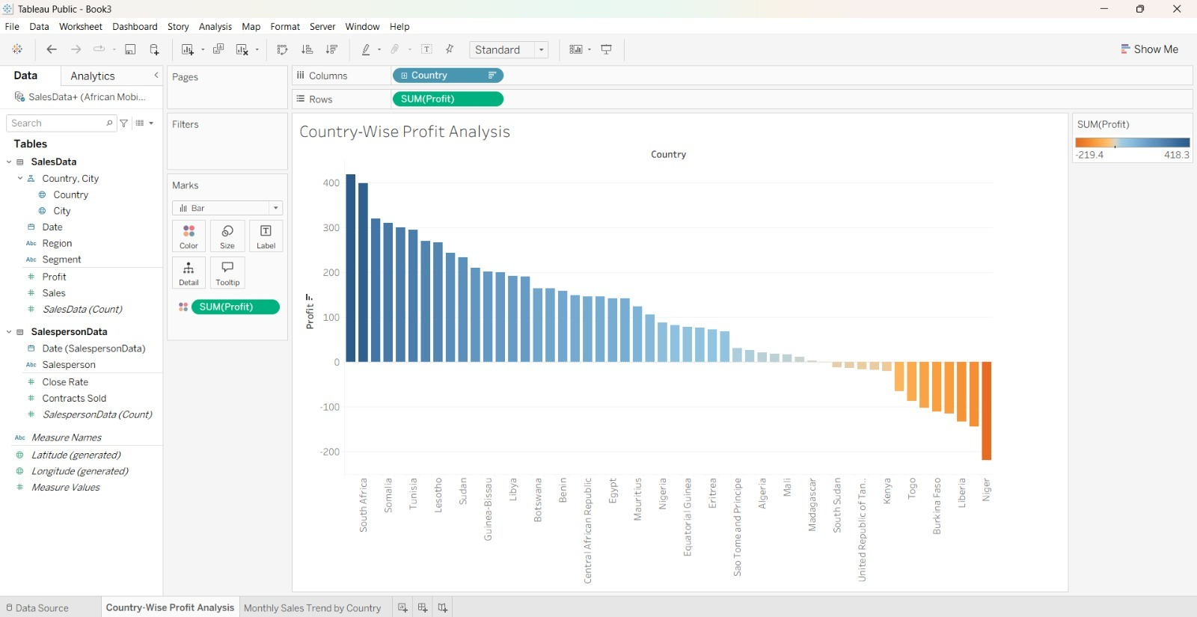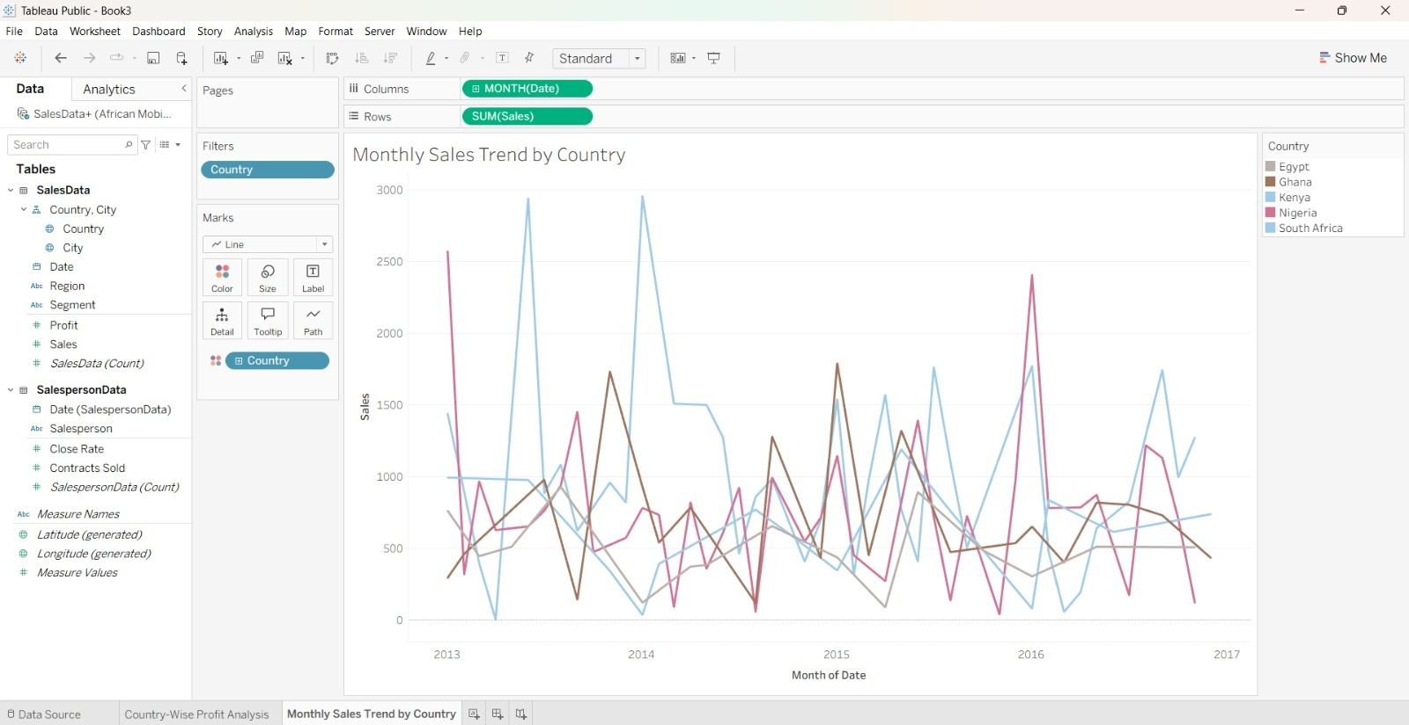
Thus, the African Mobile Data dataset was visualized using Tableau. A bar chart was created to compare the profit of different countries, and a line chart was used to analyze monthly sales trends across selected countries.”

INTERPRETATION:
The visualization helps analyze profit across different African countries and understand sales trends over time. It highlights countries with higher and lower profits and shows how sales change during the selected period. This analysis helps identify profitable markets, understand sales performance, and support better business decision-making.

